FOR IMMEDIATE RELEASE
Dust Safety Science

Contact:
Chris Cloney
Chris@dustsafetyscience.com
GLOBAL DUST SAFETY CONFERENCE ANNOUNCES KEYNOTE SPEAKERS, FULL EVENT SCHEDULE
Dust Safety Science, a leading advocate for combustible dust safety, is proud to announce the keynote speakers for the 4th annual Global Dust Safety Conference, a virtual event designed to address critical issues surrounding dust fire and explosion safety. The conference will take place February 21-23, 2024.
This year’s speakers represent a diverse range of policymakers, thought leaders, and regulatory officials from the field of dust safety. Topics include:
- Combustible Dust National Emphasis Program (NEP) results and lessons learned from recent inspections
Liliana Silvera, Chemical Process Safety Engineer - OSHA Office of Chemical Process Safety and Enforcement Initiative.
- Review, lessons learned and recommendations from the CSB investigation of the 2017 fatal combustible dust explosion at Didion Milling Inc. Cruz Redman, P.E., CSP, Chemical Incident Investigator - U.S. Chemical Safety and Hazard Investigation Board (CSB).
- Panel Discussion - Current status of NFPA 660 development and question and answer session with the experts
Ashok Dastidar,VP, Dust & Flammability Testing and Consulting - Fauske & Associates, LLC. Jason Krbec, Director of Business Development - CV Technology, Inc. Tim Myers, Principal Engineer & Office Director - Exponent, Inc. Kevin Kreitman, City Manager/Retired Fire Chief - City of Millersburg, Oregon.
- Upcoming release process for the proposed British Columbia regulations for combustible dust: why they are needed and what it means for industries in BC Rodney Scollard, Senior Policy and Legal Advisor & Mike Tasker, CRSP Occupational Safety Officer - WorkSafe BC.
Additionally, the official program featuring the full schedule of events for all three days of the conference is available now for download at https://dustsafetyconference.com/. With this program highlighting various presentations, networking opportunities, exhibitions and more, attendees can tailor their experience at the conference to their unique needs and areas of interest.
Networking Opportunities
There will be numerous opportunities to make connections with people from our industry via the advanced platform features.
- Open panel discussions with a Q&A format
- Direct message and video meetings
- Exhibition area to meet suppliers and vendors
Registration for the conference is now open. For more information and to secure your spot, please visit https://dustsafetyconference.com/
Thank you to our event sponsors!

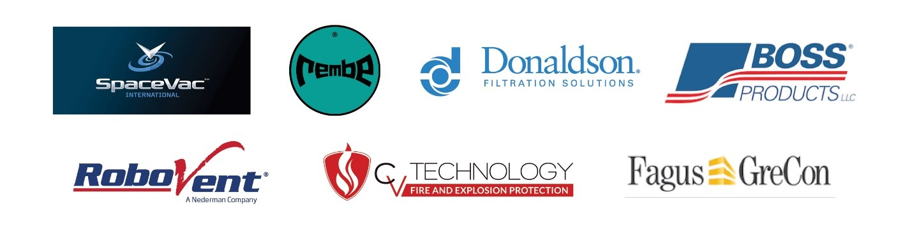

About Dust Safety Science:
Dust Safety Science is your one stop resource for all things combustible dust safety related. We help companies prevent, manage, recover from, and learn more about combustible dust incidents. Our members and community are working together to lead the way to a safer future, and a shared mission of at least one year with zero fatalities world-wide from combustible dust explosions.
Founder Chris Cloney:
Dr. Chris Cloney (PEng.) is Managing Director and Lead Researcher at DustEx Research, a company with a world-wide focus on increasing awareness of combustible dust hazards and reducing personal and financial loss from fire and explosion incidents.
Chris is a recognized expert in the field of combustible dust research publishing over 15 peer-reviewed journal articles and presenting at academic conferences in the US, Canada, China, Norway, the United Kingdom, and Poland. He is a featured public speaker having taken the stage at Explosion Safety Days 2017 in Brilon, Germany and the 2018 iPBS Powder Show in Chicago and has written industry articles featured in Powder Bulk Solids and Chemical Engineering magazines.

